ARTICLE INFORMATION
Article title
Multi-Sensor Condition-Monitoring Dataset of a Brushed DC Servo Motor
Authors
Marin Zhilevski ^{a,}*, Nikolay Yordanov ª, Danail Slavov ª
Affiliations
ª Faculty of Automatics, Technical University of Sofia, 8 Kliment Ohridski Blvd., 1000 Sofia, Bulgaria
Corresponding author’s email address and Twitter handle
mzhilevski@tu-sofia.bg
Keywords
condition monitoring; electric drives; speed regulation; current regulation; loose foundation; acoustic analysis; vibration monitoring; multimodal measurements
Abstract
Brushed permanent-magnet DC servo motors are used in industrial electromechanical systems where reliable speed control and stable operation are required. Their operation can be affected by mechanical faults and non-optimal control settings, creating a need for multi-sensor data for condition-monitoring and diagnostic research. This article presents a multi-sensor condition-monitoring dataset acquired from a brushed permanent-magnet DC servo motor (model 3PI12.06) driven by a four-quadrant thyristor converter with armature voltage and current control. The motor has rated values of 12.5 A current, 55 V DC voltage, 2.7 Nm torque, and 2000 rpm speed. Measurements were collected under no-load conditions at up to 13 rotational-speed setpoints (1, 2, 5, 10, 20, 30, 40, 50, 60, 70, 80, 90 and 100% of rated speed) under four experimental states: normal operation, a deliberately loosened mechanical foundation, suboptimal speed-regulator tuning, and suboptimal current-regulator tuning. Each experimental state was investigated without and with periodic direction reversal, resulting in eight experimental conditions. Four types of measurement data were acquired separately under the same operating conditions: armature-current waveforms recorded using a Rigol MSO5074 oscilloscope, vibration waveforms obtained from the 2.0 V AC output of an AV-160B vibrometer, airborne acoustic recordings acquired using a smartphone microphone positioned approximately 1 m from the machine, and vibrometer spot measurements of velocity, acceleration, and displacement. The armature-current signals were stored as native BIN waveforms, vibrometer waveform signals as 44.1 kHz, 16-bit stereo WAV files, smartphone recordings as AAC-encoded M4A files, and vibrometer spot measurements as XLS files. For each experimental condition and speed setpoint, the motor was brought to steady-state operation and each sensing system was recorded once, sequentially; the recordings are therefore condition-matched but not time-synchronized. The dataset contains raw, untransformed measurements together with a per-file metadata index describing the acquisition conditions and file characteristics, a README file, and the Rigol oscilloscope setup file used for the current acquisitions. The dataset may be used for exploratory research on electrical-drive condition monitoring, signal processing, and the development of data-driven methods under laboratory, no-load conditions.

SPECIFICATIONS TABLE

Subject | Engineering & Materials science
Specific subject area | Multimodal electrical, vibration and acoustic data for condition monitoring of a brushed permanent-magnet DC servo motor.
Type of data | Raw armature-current waveforms (.BIN); vibrometer waveform recordings (.WAV); smartphone acoustic recordings (.M4A); quantitative vibrometer measurements (.XLS); metadata (.CSV).
Data collection | The dataset was acquired from a brushed permanent-magnet DC servo motor (model 3PI12.06) driven by an ELL 14010 four-quadrant thyristor converter with armature voltage and current control. The motor has rated parameters of 55 V, 12.5 A, 2.7 Nm, and 2000 rpm. Measurements were performed under no-load conditions at up to 13 rotational-speed setpoints (1, 2, 5, 10, 20, 30, 40, 50, 60, 70, 80, 90 and 100% of rated speed). Four experimental states were investigated: normal operation, a deliberately loosened mechanical foundation, suboptimal speed-regulator tuning, and suboptimal current-regulator tuning. Each state was investigated without and with periodic direction reversal. Armature current was recorded using a Rigol MSO5074 oscilloscope; vibration waveforms were obtained from the 2.0 V AC output of an AV-160B vibrometer; acoustic signals were recorded using an Android smartphone microphone positioned approximately 1 m from the motor; and velocity, acceleration and displacement were recorded using the same vibrometer. Each operating point was recorded once, sequentially (15–25 June 2026); the recordings are condition-matched, not synchronized.
Data source location | Laboratory of Technical University of Sofia, Sofia, Bulgaria
Data accessibility | Repository name: Mendeley Data  Data identification number: DOI: 10.17632/g28trvywnx.12  Direct URL to data: https://data.mendeley.com/datasets/g28trvywnx/12
Related research article | The dataset is related to a previously published research article based on measurements performed using the same experimental setup. Compared with the measurements reported in the related article, the present dataset provides an expanded and systematically organized collection of raw measurements, including armature-current waveforms, vibrometer waveform recordings, smartphone acoustic recordings, and vibrometer spot measurements collected under multiple operating conditions.  The published research article is: N. Yordanov, M. Zhilevski, M. Mikhov, O. Krol and V. Sokolov, “VIBRO-ACOUSTIC ANALYSIS OF LOOSE FOUNDATION EFFECTS IN ELECTRIC MOTORS AT VARYING ROTATIONAL SPEEDS,” International Journal of Mechatronics and Applied Mechanics (IJOMAM), Issue 22, Volume II, 2025, pp. 125–131, doi: 10.17683/ijomam/issue22.v2.12.

VALUE OF THE DATA
- Researchers, students and engineers in electrical drives, condition monitoring and signal processing can use the dataset, which provides multimodal electrical, vibration and acoustic measurements from a brushed permanent-magnet DC servo motor under different mechanical and control-related operating conditions.
- The dataset combines armature-current waveforms, vibrometer waveform recordings, smartphone acoustic recordings, and quantitative vibrometer measurements, enabling comparison of sensing modalities at matched operating conditions (recorded sequentially, not synchronized).
- The data cover normal operation, a deliberately loosened mechanical foundation, suboptimal speed-regulator tuning, and suboptimal current-regulator tuning, with measurements acquired both without and with periodic direction reversal.
- The systematic acquisition at up to 13 rotational-speed setpoints under no-load conditions provides data for examining electrical, vibration and acoustic measurements across different commanded speed levels.
- The availability of smartphone acoustic recordings together with instrument-based vibration measurements provides a basis for comparing airborne acoustic recordings with vibrometer-based measurements.
- The raw and untransformed data can be reused for signal-processing studies, exploratory feature extraction and development of data-driven methods; results obtained on this single-motor, no-load laboratory dataset should be validated on other machines before generalization. For machine-learning studies, grouped splits by operating point (e.g., leave-one-speed-out) are recommended.

BACKGROUND
Condition monitoring of electric drives commonly relies on electrical, vibration and acoustic measurements to characterize changes in machine and drive operation. Armature-current analysis has been investigated for the diagnosis of permanent-magnet DC motors, while vibration measurements are widely used to detect changes in mechanical conditions [1]. Acoustic measurements provide a non-contact sensing modality, and the use of smartphone microphones for electrical-machine monitoring has also been reported [2]. Recent datasets have combined current, vibration and acoustic measurements for rotating-machine condition monitoring [3,4], while smartphone-based sensing has been used for motor diagnosis under different operating conditions [5].
The present dataset was motivated by the need to compile a newly acquired and systematically organized multimodal dataset from a brushed permanent-magnet DC servo motor under different mechanical and control-related operating states. The experimental approach was based on previous work performed using the same laboratory setup, in which vibro-acoustic measurements were used to investigate the effects of a deliberately loosened foundation at different rotational speeds [6]. The measurements included in the present dataset were newly acquired and were not reused from that study. The current dataset extends the measurement scope by including armature-current waveforms, vibrometer waveform recordings, smartphone acoustic recordings, and quantitative vibrometer measurements for four experimental states, investigated without and with periodic direction reversal, and at up to 13 rotational-speed setpoints under no-load conditions. Unlike existing datasets, which cover brushless DC motors [3] or induction motors [4,5], the present dataset concerns a brushed permanent-magnet DC servo drive and includes, besides a mechanical abnormality, two controller-tuning states. Compared with [6], it adds armature-current recordings, the controller-tuning states, operation with direction reversal and 13 speed setpoints.

DATA DESCRIPTION
The dataset contains raw multi-sensor recordings acquired from a single brushed permanent-magnet DC servo motor installed on a laboratory experimental test rig. The recordings are organized according to experimental condition, sensing modality and speed setpoint. The repository contains raw armature-current waveforms, vibrometer waveform recordings, smartphone acoustic recordings and quantitative vibrometer measurements, together with a Rigol oscilloscope setup file used for the current acquisitions, a per-file metadata index, a README descriptor and a license file. The repository contains 386 data files (98 BIN, 98 WAV, 98 M4A, 91 XLS and one STP file), together with metadata.csv, README.md, LICENSE.txt and a quality/ folder with the quality-check script, per-file results and SHA-256 checksums. The overall organization of the dataset repository is presented in Table 1.Table 1.
Organization of the dataset repository.
Folder/File | Description | Format
data/ | Raw measurements organized by experimental condition and sensor modality | Folder
scope_setup/ | Rigol oscilloscope setup file (1v_3v0.stp) | Folder/STP
quality/ | Data-quality check script (qc_report.py), which also contains readers for all file formats; list of required Python packages (requirements.txt); per-file results (qc_per_file.csv); and SHA-256 checksums (checksums_sha256.txt) | Folder/PY, CSV, TXT
metadata.csv | Per-file metadata index containing acquisition and traceability information | CSV
README.md | Dataset descriptor containing information on the motor, experimental conditions, sensors, acquisition procedure and repository structure | Markdown
LICENSE.txt | Creative Commons Attribution 4.0 International license | TXT
The machine under test is a brushed permanent-magnet DC servo motor, designated 3PI12.06, driven by ELL 14010 four-quadrant thyristor converter providing armature voltage and current control. The rated parameters of the motor under investigation are presented in Table 2.

Table 2.
Rated parameters of the machine under test.
Parameter | Value
Type | Brushed permanent-magnet DC servo
Designation | 3PI12.06
Rated voltage | 55 V
Rated current | 12.5 A
Rated torque | 2.7 Nm
Rated speed | 2000 rpm
Drive | ELL 14010 Four-quadrant thyristor converter

The measurements were acquired with the motor operating without an external mechanical load. The motor was operated at commanded speed setpoints expressed as a percentage of the rated speed. The nominal speed setpoints were 1, 2, 5, 10, 20, 30, 40, 50, 60, 70, 80, 90 and 100% of the rated speed. For the suboptimal_control_ conditions, the available speed setpoints were limited to 1, 2, 5, 10, 20, 30, 40, 50, 60 and 65% of the rated speed.
Four experimental states were investigated: normal operation, a deliberately loosened mechanical foundation, suboptimal speed-regulator tuning, and suboptimal current-regulator tuning. The suboptimal_control_ conditions correspond to a non-optimal speed-regulator gain with the current regulator at its nominal setting, whereas the suboptimal_control_rt_ conditions correspond to a non-optimal current-regulator gain with the speed regulator at its nominal setting (Table 7). Each operating state was investigated without and with periodic reversal of the motor rotation direction, resulting in eight experimental conditions. Table 3 presents the operating conditions and speed setpoints represented in the dataset.
Each experimental-condition folder contains up to four sensor subfolders: current/, sound_vibrometer/, sound_phone/ and vibration/. Table 4 summarizes the sensor channels, acquisition instruments and file formats. The current/ files contain armature-current waveforms acquired using the Rigol MSO5074 oscilloscope and stored as native binary .BIN files. The sound_vibrometer/ files contain waveform recordings obtained from the 2.0 V AC analog output of the AV-160B vibrometer and stored as 44.1 kHz, 16-bit, stereo.WAV files. The sound_phone/ files contain airborne acoustic recordings acquired using an Android smartphone microphone positioned approximately 1 m from the motor and stored as AAC-encoded .M4A files. The vibration/ files contain velocity, acceleration and displacement measurements obtained using the AV-160B vibrometer in display mode and stored as .XLS files.

Table 3.
Operating conditions and available speed setpoints.
Folder (data/) | Operation | Reversal | Speed setpoints (% of rated speed)
normal_no_reversal | Normal operation | No | 1, 2, 5, 10, 20, 30, 40, 50, 60, 70, 80, 90, 100
normal_with_reversal | Normal operation | Yes | 1, 2, 5, 10, 20, 30, 40, 50, 60, 70, 80, 90, 100
suboptimal_control_no_reversal | Suboptimal speed-regulator tuning | No | 1, 2, 5, 10, 20, 30, 40, 50, 60, 65
suboptimal_control_with_reversal | Suboptimal speed-regulator tuning | Yes | 1, 2, 5, 10, 20, 30, 40, 50, 60, 65
suboptimal_control_rt_no_reversal | Suboptimal current-regulator tuning | No | 1, 2, 5, 10, 20, 30, 40, 50, 60, 70, 80, 90, 100
suboptimal_control_rt_with_reversal | Suboptimal current-regulator tuning | Yes | 1, 2, 5, 10, 20, 30, 40, 50, 60, 70, 80, 90, 100
loose_foundation_no_reversal | Loose foundation | No | 1, 2, 5, 10, 20, 30, 40, 50, 60, 70, 80, 90, 100
loose_foundation_with_reversal | Loose foundation | Yes | 1, 2, 5, 10, 20, 30, 40, 50, 60, 70, 80, 90, 100

All recordings were acquired from a single motor on one laboratory test rig during one measurement campaign (15–25 June 2026). Each combination of experimental condition and commanded speed setpoint is referred to as an operating point. At each operating point, the motor was brought to steady-state operation and each sensing system was then recorded once, one after another, in the order armature current, vibrometer waveform, smartphone audio and vibrometer spot measurements; the time between recordings was not logged. No operating point was repeated. The recordings of one operating point are therefore condition-matched but not time-synchronized; neither they nor segments cut from a single recording should be treated as independent observations or used for sample-level sensor fusion.
The measurement files follow the naming convention speedNNN_sensor.ext, where NNN denotes the zero-padded commanded speed setpoint expressed as a percentage of the rated speed. For example, speed020 corresponds to a commanded speed setpoint of 20% of the rated speed. The files are organized under data/<condition>/<sensor>/.

Table 4.
Sensor channels, instruments and file formats.
Sub-folder | Measurement | Instrument | Format | Sampling / notes
current/ | Armature current waveform | Rigol MSO5074 oscilloscope | .bin | Native binary waveform; sampling rate and scaling stored in file header; values in V, proportional to armature current (conversion factor to A not recorded)
sound_vibrometer/ | Vibrometer waveform | AV-160B vibrometer, AC output | .wav | 44.1 kHz, 16-bit, stereo
sound_phone/ | Airborne acoustic signal | Android smartphone microphone | .m4a | AAC encoded
vibration/ | Velocity, acceleration and displacement | AV-160B vibrometer, display mode | .xls | Spot measurements according to ISO 2954

Table 5.
Fields included in metadata.csv.
Field | Description
condition | Experimental-condition key corresponding to the data/ subfolder
operation | Experimental operating state
reversal | Periodic direction reversal (yes/no)
speed_percent | Commanded speed setpoint expressed as a percentage of rated speed
sensor | Sensor modality (current, sound_vibrometer, sound_phone, vibration)
format | File format (bin, wav, m4a, xls)
sample_rate_hz | Sampling rate, where applicable
duration_s | Recording duration, where applicable
channels | Number of channels, where applicable
bit_depth | Bits per sample, where applicable
file_size_bytes | File size in bytes
new_path | File path within the repository
original_name | Original raw file name
original_path | Original raw folder path

The metadata.csv file provides a structured index of the files in the repository. It contains information describing the experimental condition, operation state, reversal mode, speed setpoint, sensor modality, file format and selected acquisition characteristics, together with file-size and path information for traceability. Table 5 describes the fields included in metadata.csv.
Table 6 summarizes the number of measurement files available for each experimental condition and sensing modality. The repository contains 385 measurement files, comprising 98 armature-current files, 98 vibrometer waveform files, 98 smartphone acoustic files and 91 quantitative vibrometer measurement files. These measurement files are complemented by the Rigol oscilloscope setup file used for the current acquisitions 1v_3v0.stp in the scope_setup/ folder, resulting in 386 data files in total. The seven missing vibrometer spot-measurement files correspond to the 1% and 2% speed setpoints, at which the vibration level was below the detection threshold of the instrument (Table 6; README, Section 8).

Table 6.
Number of measurement files per experimental condition and sensor.
Condition | Current | Vibrometer waveform | Smartphone audio | Vibrometer measurements | Total
normal_no_reversal | 13 | 13 | 13 | 11 | 50
normal_with_reversal | 13 | 13 | 13 | 12 | 51
suboptimal_control_no_reversal | 10 | 10 | 10 | 8 | 38
suboptimal_control_with_reversal | 10 | 10 | 10 | 10 | 40
suboptimal_control_rt_no_reversal | 13 | 13 | 13 | 13 | 52
suboptimal_control_rt_with_reversal | 13 | 13 | 13 | 13 | 52
loose_foundation_no_reversal | 13 | 13 | 13 | 11 | 50
loose_foundation_with_reversal | 13 | 13 | 13 | 13 | 52
Total | 98 | 98 | 98 | 91 | 385
One current file (normal_with_reversal, 100%) is incomplete; see Data Description.
All 385 measurement files were checked automatically for completeness, agreement with metadata.csv, duplicate files (SHA-256 checksums), clipping, and flat or silent segments; per-file results and checksums are provided in the repository (README, Section 8; quality/ folder). No duplicate files were found, and all files except one agreed with the sampling rate and duration given in metadata.csv. One armature-current file (normal_with_reversal, 100% setpoint) is incomplete, containing 11.3 s of the expected 20 s; it is retained as recorded and flagged in the repository. Clipping was detected in 94 of the 98 vibrometer waveform files, affecting at most 0.93% of samples per file; for the current files, clipping cannot be assessed from the stored data. All vibrometer waveform and smartphone recordings begin with a short silent segment (about 0.27 s and 0.40 s, respectively), which is consistent across files and should be excluded from steady-state analysis. The Python script used for these checks (quality/qc_report.py) is included in the repository; it also contains readers for all file formats (BIN, WAV, M4A, XLS and metadata.csv) and can be used to load and convert the recordings. An example of reading a current file and a sample of the converted data are given in the README (Section 7).
The overall organization of the multi-sensor dataset repository is illustrated in Fig. 1.

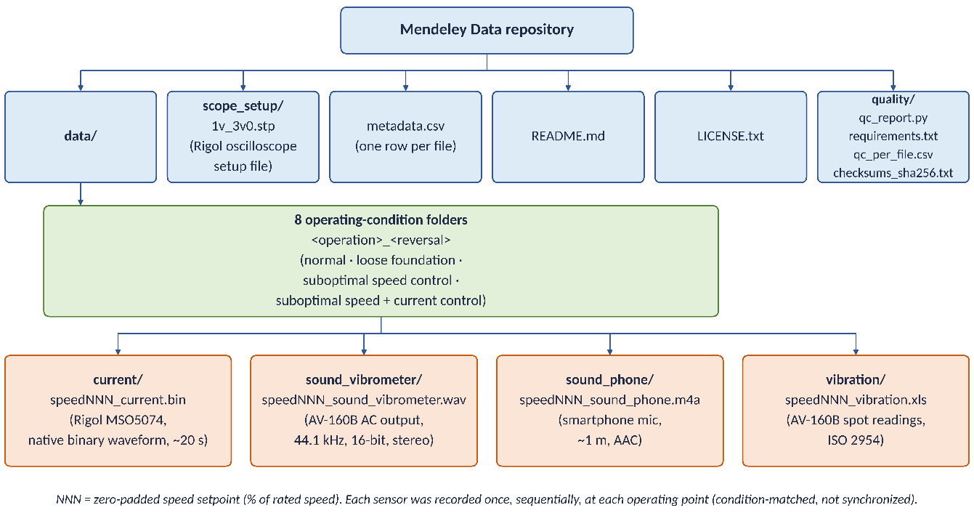
Fig. 1. Organization of the multi-sensor dataset repository.

Figures 2–4 show representative examples of the raw data included in the dataset. Figure 2 presents the armature-current waveform and its amplitude spectrum for normal operation without direction reversal at a 50% speed setpoint. Figure 3 presents the corresponding vibrometer vibration waveform and spectrogram for the same operating condition. Figure 4 presents the AV-160B spot measurements of vibration velocity, acceleration and displacement over the available speed setpoints for normal operation without direction reversal. The figures were generated in Python directly from the raw files (BIN files parsed with the struct module and NumPy, WAV files with the wave module, XLS files with xlrd; FFT and descriptive statistics computed with NumPy; plots and spectrogram produced with Matplotlib) and illustrate the types and formats of the measurements without additional interpretation.

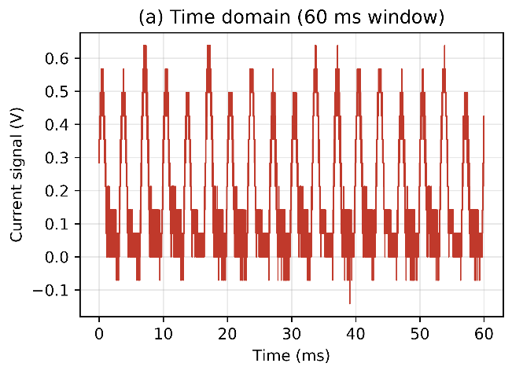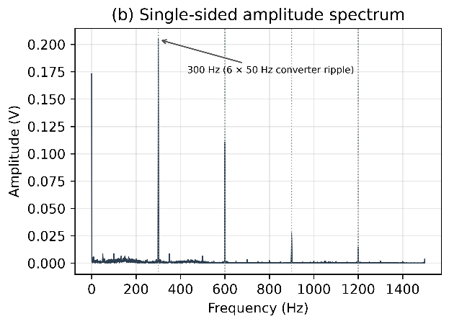
a) b)
Fig. 2. Representative armature-current recording for normal operation without direction reversal at a 50% speed setpoint: (a) time-domain signal (first 60 ms shown) and (b) single-sided amplitude spectrum. Values are the recorded signal voltage, proportional to the armature current. The spectrum was computed from the first 2 s of the recording (sampling rate 1 MHz; FFT length 2,000,000 samples; symmetric Hann window with coherent-gain correction; frequency resolution 0.5 Hz; no averaging, detrending, mean removal or zero-padding). The 300 Hz component corresponds to the six-pulse ripple of the thyristor converter supplied from the 50 Hz mains (6 × 50 Hz).
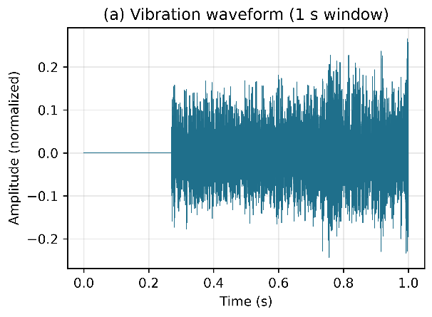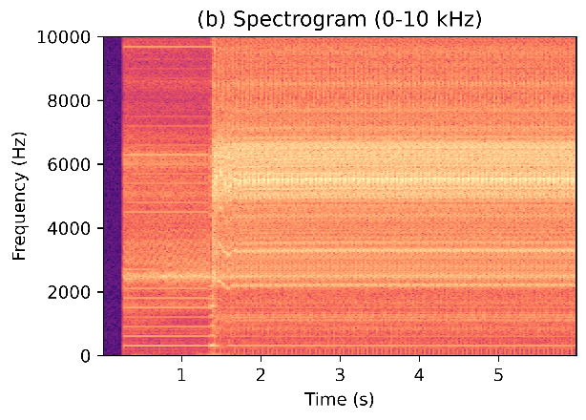
a) b)
Fig. 3. Representative vibrometer waveform recording for normal operation without direction reversal at a 50% speed setpoint: (a) time-domain waveform (first 1 s shown), with amplitude normalized to the digital full scale of the 16-bit WAV file (±1 corresponds to ±32,768 counts), and (b) spectrogram (first 6 s). The initial silent segment (about 0.27 s) is present in all vibrometer waveform recordings.

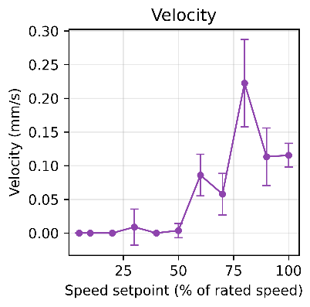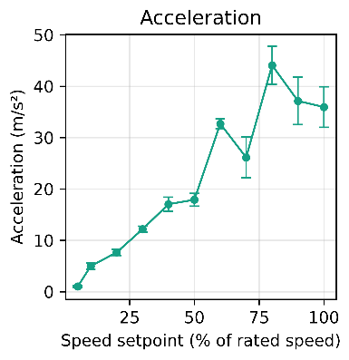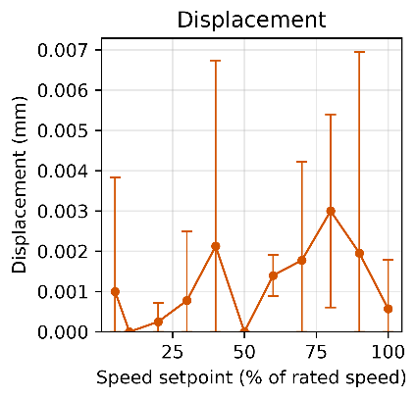
a) b) c)
Fig. 4. AV-160B spot measurements of vibration: (a) velocity, (b) acceleration and (c) displacement over the available speed setpoints for normal operation without direction reversal. Markers show the mean, and error bars indicate ±1 sample standard deviation, calculated from 8–22 readings per quantity at each setpoint. Velocity is reported as true RMS, acceleration as equivalent peak, and displacement as equivalent peak-to-peak, as defined by the instrument specification. Displacement values are close to the instrument resolution (0.001 mm).

The complete dataset is publicly available through the Mendeley Data repository [7].

EXPERIMENTAL DESIGN, MATERIALS AND METHODS
The experimental investigation was performed using the laboratory test rig shown in Fig. 5, with its main components and regulator-setting interface presented in Fig. 6. The test rig incorporates the brushed permanent-magnet DC servo motor described in Table 2, a four-quadrant thyristor converter for armature voltage and current control, measurement equipment, and a control and data-acquisition interface. The motor was operated without an external mechanical load during the entire experimental campaign.

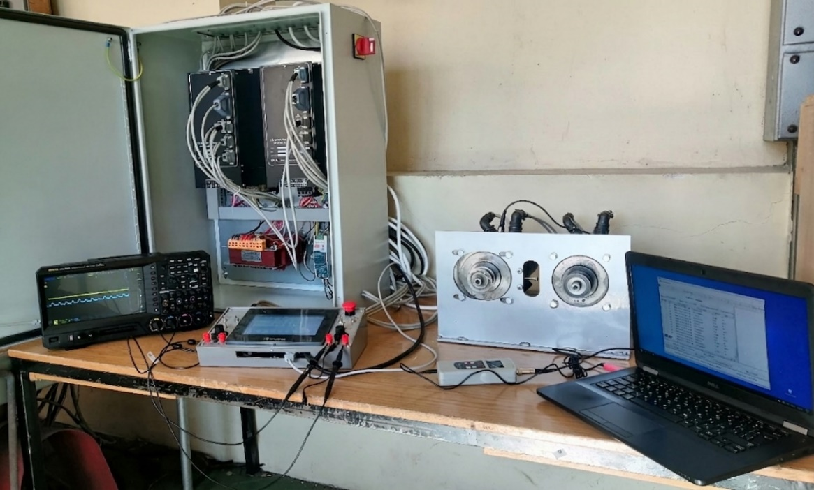
Fig. 5. Laboratory experimental test rig used for acquisition of the multi-sensor dataset.

The motor was operated at commanded speed setpoints expressed as a percentage of its rated speed. The nominal speed setpoints were 1, 2, 5, 10, 20, 30, 40, 50, 60, 70, 80, 90 and 100% of the rated speed. For the suboptimal speed-regulator condition, the available speed setpoints were limited to 1, 2, 5, 10, 20, 30, 40, 50, 60 and 65% of the rated speed. The suboptimal current-regulator condition was investigated over the full speed range from 1 to 100% using the nominal speed setpoints. The corresponding speed setpoints for each experimental condition are given in Table 3.
Four experimental states were investigated. The first state represented normal operation with the nominal adjustment of the electric-drive control system. The second state was obtained by loosening all four mounting bolts of the motor by hand until the motor base could be moved slightly by hand; the tightening torque and the degree of loosening were not measured. The third state represented suboptimal speed-regulator tuning, obtained by reducing the speed-regulator proportional gain (P05.04) from its nominal value of 10 to 0.2 while the current regulator remained at its nominal setting. The fourth state represented suboptimal current-regulator tuning, obtained by reducing the current-regulator proportional gain (P06.02) from its nominal value of 2 to 0.1 while the speed regulator remained at its nominal setting. The settings defining each state are listed in Table 7.
Table 7.
Settings defining the experimental states.
State | What was changed | Setting
Normal operation | Reference (nominal controller settings) | P05.04 (speed-regulator gain Kp2) = 10; P06.02 (current-regulator gain Kp1) = 2
Suboptimal speed-regulator tuning | Speed-regulator gain; current regulator nominal | P05.04: 10 → 0.2 (−98%)
Suboptimal current-regulator tuning | Current-regulator gain; speed regulator nominal | P06.02: 2 → 0.1 (−95%)
Loose foundation | Mounting bolts loosened | 4 of 4 mounting bolts loosened by hand; tightening torque and degree of loosening not measured
Direction reversal | Periodic reversal of rotation | Manual switch, approximately every 4 s (operator timed against a clock); reversal instants not logged

The regulator gain parameters were adjusted through the drive-system control panel. The procedure for accessing the speed-regulator settings and modifying the corresponding gain coefficient is illustrated in Fig. 6(c,d), while the current-regulator gain setting is shown in Fig. 6(e).

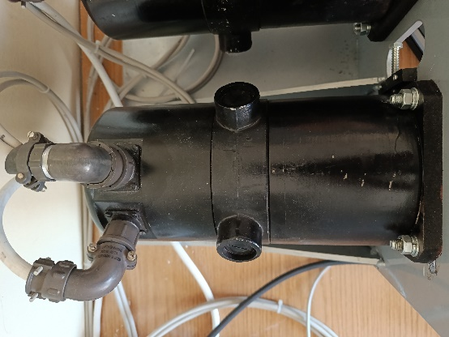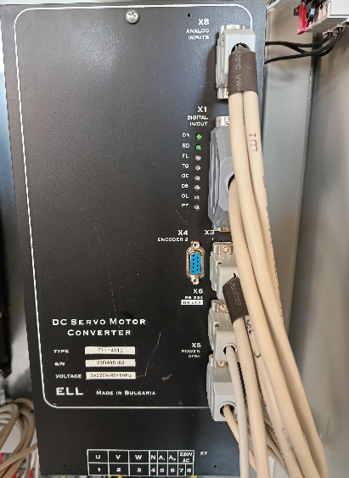
a) b)
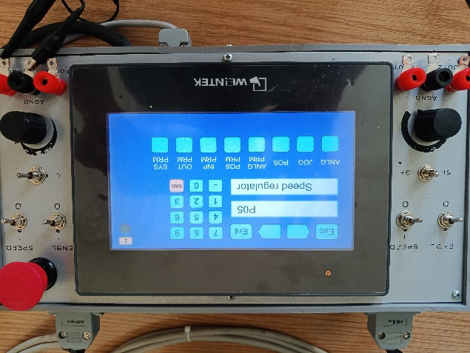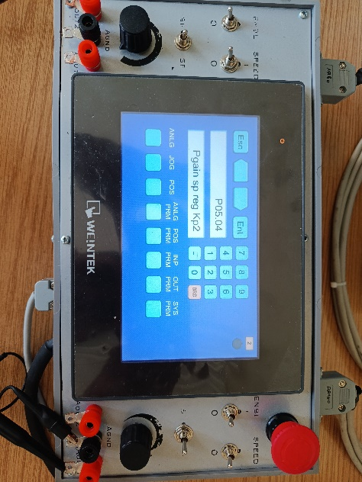
c) d)
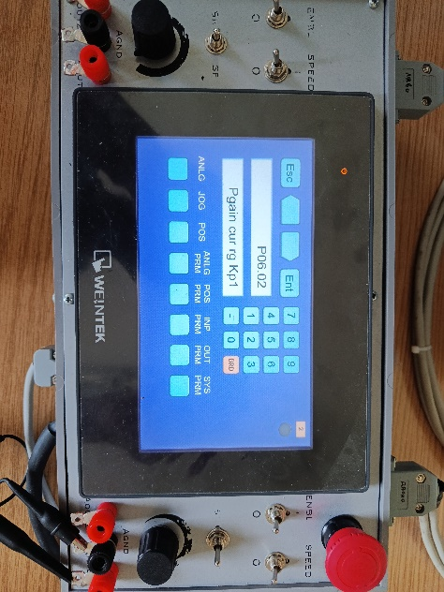
e)
Fig. 6. Main components of the experimental setup and procedure for adjusting the speed- and current-regulator gain coefficients: (a) brushed permanent-magnet DC servo motor; (b) ELL 14010 four-quadrant thyristor converter; (c) access to the speed-regulator settings; (d) speed-regulator gain coefficient; and (e) current-regulator gain coefficient.
Each experimental state was investigated in two rotational modes: continuous rotation in one direction without reversal and periodic reversal of the motor rotation direction. Consequently, eight experimental conditions were considered:
- normal operation without direction reversal;
- normal operation with direction reversal;
- loose foundation without direction reversal;
- loose foundation with direction reversal;
- suboptimal speed-regulator tuning without direction reversal;
- suboptimal speed-regulator tuning with direction reversal;
- suboptimal current-regulator tuning without direction reversal;
- suboptimal current-regulator tuning with direction reversal.

Table 8.
Measurement equipment used for data acquisition.
Equipment | Model / specification | Purpose
Brushed permanent-magnet DC servo motor | 3PI12.06 | Machine under test
Power converter | ELL 14010, four-quadrant thyristor converter | Armature voltage and current control
Oscilloscope | Rigol MSO5074 | Armature-current waveform acquisition
Vibrometer | AV-160B (Amittari) with external piezoelectric probe | Vibration waveform and quantitative vibration measurements
Smartphone | Huawei P smart Z (Android), hand-held at approx. 1 m, motor height | Airborne acoustic signal acquisition

Four measurement modalities were used during the experimental campaign: armature current, vibration waveform, airborne acoustic signal and quantitative vibration measurements. The measurement equipment used for data acquisition is summarized in Table 8. The individual sensing systems were operated sequentially under the same experimental conditions rather than simultaneously.
The armature-current signal was recorded on channel 1 of a Rigol MSO5074 digital oscilloscope (DC coupling, 1 V/div, −3 V offset, probe ratio 1X, 1 MS/s, 20 s record; the oscilloscope settings are provided in scope_setup/1v_3v0.stp) and stored in the native binary format (.BIN), with the sampling interval and vertical scaling in each file header. The stored values are the voltage of a signal proportional to the armature current; the conversion factor to amperes was not recorded, so the current data should be used as relative values.
Vibration waveform measurements were acquired using an AV-160B vibrometer (Amittari) equipped with an external piezoelectric probe. The 2.0 V AC analog output of the vibrometer was recorded as a 44.1 kHz, 16-bit, stereo WAV signal.
The same AV-160B vibrometer was also used to obtain quantitative vibration measurements in display mode. Vibration velocity, acceleration and displacement values were recorded as spot measurements in XLS format. The measurements were obtained according to the measurement procedure specified for the instrument and were associated with ISO 2954.
Airborne acoustic measurements were acquired using an Android smartphone (Huawei P smart Z) held by hand approximately 1 m from the motor, at the height of the motor, with the bottom edge of the phone (microphone side) not facing the motor. The recordings were stored as AAC-encoded M4A files. The smartphone's built-in audio processing settings (e.g., automatic gain control or noise suppression) were not documented, so the acoustic recordings should be used as relative levels.
For each experimental condition and speed setpoint, the motor was first adjusted to the required commanded speed and allowed to reach steady-state operation (judged visually from the oscilloscope signal; no quantitative criterion was applied). The individual measurement systems were then operated sequentially while maintaining the same experimental condition and speed setpoint.
The armature-current waveform was acquired using the Rigol MSO5074 oscilloscope. The vibration waveform was subsequently recorded from the AC analog output of the AV-160B vibrometer. The airborne acoustic signal was then recorded using the smartphone microphone positioned approximately 1m from the motor. Finally, the velocity, acceleration and displacement values displayed by the AV-160B vibrometer were recorded as spot measurements.
The procedure was repeated for the required speed setpoints for each of the eight experimental conditions. For the conditions involving periodic direction reversal, the rotation direction was reversed manually with a switch, approximately every 4 s (timed by the operator against a clock), while the corresponding operating condition and commanded speed setpoint were maintained. Because the reversals were triggered manually, their instants are not exactly periodic and were not logged.
The files were named using the speedNNN_sensor.ext convention, where NNN represents the zero-padded commanded speed setpoint expressed as a percentage of rated speed. The metadata.csv file was prepared to provide file-level traceability, including the experimental condition, operation state, reversal mode, speed setpoint, sensor modality, file format and available acquisition parameters, together with file-size and original file-path information.
No signal transformation was applied during dataset preparation. The raw recordings were retained in their original acquisition formats, without filtering, resampling, feature extraction or other signal-processing operations. The integrity and quality checks applied to the files are described in the Data Description section. The repository was supplemented with the Rigol oscilloscope setup file used for the current acquisitions (1v_3v0.stp), metadata.csv, README.md and LICENSE.txt.

LIMITATIONS
The dataset has several limitations related to the experimental setup and data acquisition procedure. First, the measurements were obtained from a single brushed permanent-magnet DC servo motor and one laboratory test rig; therefore, the dataset does not cover variations between different motor designs, manufacturers or drive configurations. Second, all measurements were performed under no-load conditions, and externally applied mechanical load levels were not included. Third, the four sensing modalities were acquired sequentially rather than simultaneously and each operating point was recorded only once, so no independent repetitions are available. Fourth, the coverage of the speed setpoints is not identical for all sensor modalities and experimental conditions. In particular, the suboptimal speed-regulator condition was limited to a maximum commanded speed of 65% of rated speed, while some low-speed vibration spot measurements are not available; in addition, one current recording is incomplete (11.3 s instead of 20 s), and a small fraction of samples (at most 0.93%) is clipped in most vibrometer waveform files. The current signals are provided in volts and are proportional to the armature current; the conversion factor to amperes was not recorded, so absolute current values cannot be derived. In the reversal conditions, the direction changes were triggered manually at approximately 4 s intervals, so their timing is not exactly periodic and is not logged. The smartphone was hand-held at approximately 1 m, so the microphone position was not fixed between recordings, and its built-in audio processing settings were not documented and ambient acoustic conditions were not controlled; the acoustic recordings are therefore suited to relative comparisons. Finally, the loose-foundation condition was introduced by loosening the mounting bolts by hand without measuring the torque or the degree of loosening; it therefore represents a single, unquantified severity level on the laboratory test rig rather than a naturally occurring fault recorded during industrial operation. The dataset is intended for research use; it does not establish diagnostic performance, machine-independent generalizability or industrial applicability.

ETHICS STATEMENT
The authors have read and followed the ethical requirements for publication in Data in Brief. The present work does not involve human subjects, animal experiments, or data collected from social media platforms.

CRediT AUTHOR STATEMENT
Marin Zhilevski: Conceptualization, Methodology, Investigation, Data curation, Visualization, Writing – Original Draft, Writing – Review & Editing, Supervision.
Danail Slavov: Methodology, Investigation, Software, Data curation.
Nikolay Yordanov: Methodology, Software, Data curation.

ACKNOWLEDGEMENTS
The authors would like to thank the Research and Development Sector at the Technical University of Sofia for the financial support.

DECLARATION OF COMPETING INTERESTS
The authors declare that they have no known competing financial interests or personal relationships that could have appeared to influence the work reported in this paper.

DECLARATION OF GENERATIVE AI AND AI-ASSISTED TECHNOLOGIES IN THE MANUSCRIPT PREPARATION PROCESS
During the preparation of this work, the authors used GitHub Copilot with Anthropic Claude Sonnet 4.8 and 5 models to assist in developing and debugging the Python scripts used to curate and validate the dataset and to generate the figures, in drafting the README and documentation files, and in drafting and language editing of selected parts of the manuscript. No experimental data were generated by AI; all acoustic recordings and vibration measurements are original experimental data acquired by the authors. All AI-assisted outputs were reviewed, verified, and edited by the authors as necessary. The authors take full responsibility for the content of the published article and dataset.

REFERENCES
[1] M. Iorgulescu and R. Beloiu, "Study of DC Motor Diagnosis Based on the Vibration Spectrum and Current Analysis," in Proc. 2012 International Conference on Applied and Theoretical Electricity (ICATE), Craiova, Romania, 2012, doi: 10.1109/ICATE.2012.6403430.
[2] T. Vaimann, J. Sobra, A. Belahcen, A. Rassõlkin, M. Rolak, and A. Kallaste, “Induction machine fault detection using smartphone recorded audible noise,” IET Science, Measurement & Technology, vol. 12, no. 4, pp. 554–560, 2018, doi: 10.1049/iet-smt.2017.0104.
[3] R. S. Prieto Estacio, D. A. Bravo Montenegro, and C. F. Rengifo Rodas, “Dataset of audio signals from brushless DC motors for predictive maintenance,” Data in Brief, vol. 50, 109569, 2023, doi: 10.1016/j.dib.2023.109569.
[4] W. Jung, S.-H. Kim, S.-H. Yun, J. Bae, and Y.-H. Park, “Vibration, acoustic, temperature, and motor current dataset of rotating machine under varying operating conditions for fault diagnosis,” Data in Brief, vol. 48, 109049, 2023, doi: 10.1016/j.dib.2023.109049.
[5] M. Ertarğın, A. Orhan, Ö. Yıldırım, S. Chauhan, and G. Vashishtha, “A smartphone-based vibration dataset for induction motor fault diagnosis under different speed and load conditions,” Data in Brief, vol. 67, 112916, 2026, doi: 10.1016/j.dib.2026.112916.
[6] N. Yordanov, M. Zhilevski, M. Mikhov, O. Krol, and V. Sokolov, “VIBRO-ACOUSTIC ANALYSIS OF LOOSE FOUNDATION EFFECTS IN ELECTRIC MOTORS AT VARYING ROTATIONAL SPEEDS,” International Journal of Mechatronics and Applied Mechanics, Issue 22, Volume II, 2025, pp. 125–131, doi: 10.17683/ijomam/issue22.v2.12.
[7] M. Zhilevski, D. Slavov, N. Yordanov, “Multi-Sensor Condition-Monitoring Dataset of a Brushed DC Servo Motor”, Mendeley Data, 2026, doi: 10.17632/g28trvywnx/13

